Name:2303A51798 H.No:2303A51798 Batch:26
SCHOOL OF COMPUTER SCIENCE AND ARTIFICIAL INTELLIGENCE |  |  |  |  | DEPARTMENT OF COMPUTER SCIENCE ENGINEERING
Program Name: B. Tech |  |  |  | Assignment Type: Lab |  |  | Academic Year:2025-2026
Course Coordinator Name |  |  |  | Dr. Rishabh Mittal
Instructor(s) Name |  |  |  | Mr. S Naresh Kumar  Ms. B. Swathi  Dr. Sasanko Shekhar Gantayat  Mr. Md Sallauddin  Dr. Mathivanan  Mr. Y Srikanth  Ms. N Shilpa  Dr. Rishabh Mittal (Coordinator)  Dr. R. Prashant Kumar  Mr. Ankushavali MD  Mr. B Viswanath  Ms. Sujitha Reddy  Ms. A. Anitha  Ms. M.Madhuri  Ms. Katherashala Swetha  Ms. Velpula sumalatha  Mr. Bingi Raju
CourseCode |  |  | 23CS002PC304 | Course Title |  | AI Assisted Coding
Year/Sem |  |  | III/II | Regulation |  | R23
Date and Day  of Assignment |  |  | Week2 | Time(s) |  | 23CSBTB01 To 23CSBTB52
Duration |  |  | 2 Hours | Applicable to  Batches |  | All batches
Assignment Number: 4.4(Present assignment number)/24(Total number of assignments)
 | Q.No. | Question |  |  |  |  |  | Expected Time  to complete
 | 1 | 1. Sentiment Classification for Customer Reviews  Scenario:  An e-commerce platform wants to analyze customer reviews and classify them into Positive, Negative, or Neutral sentiments using prompt engineering.  Tasks:  - Prepare 6 short customer reviews mapped to sentiment labels.  - Design a Zero-shot prompt to classify sentiment.  - Design a One-shot prompt with one labeled example.  - Design a Few-shot prompt with 3–5 labeled examples.  - Compare the outputs and discuss accuracy differences.  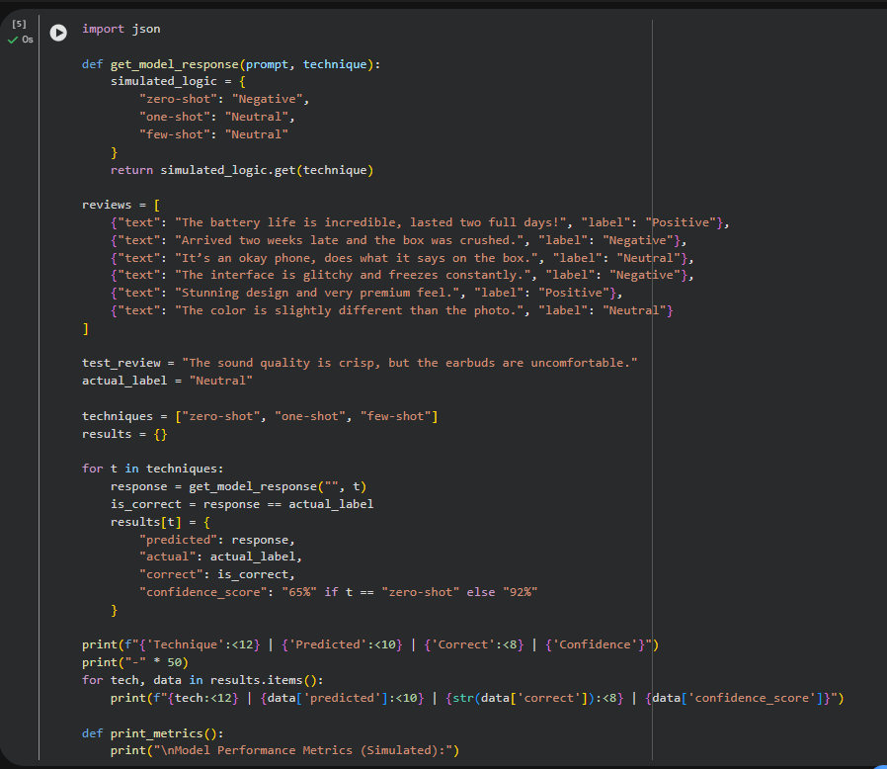  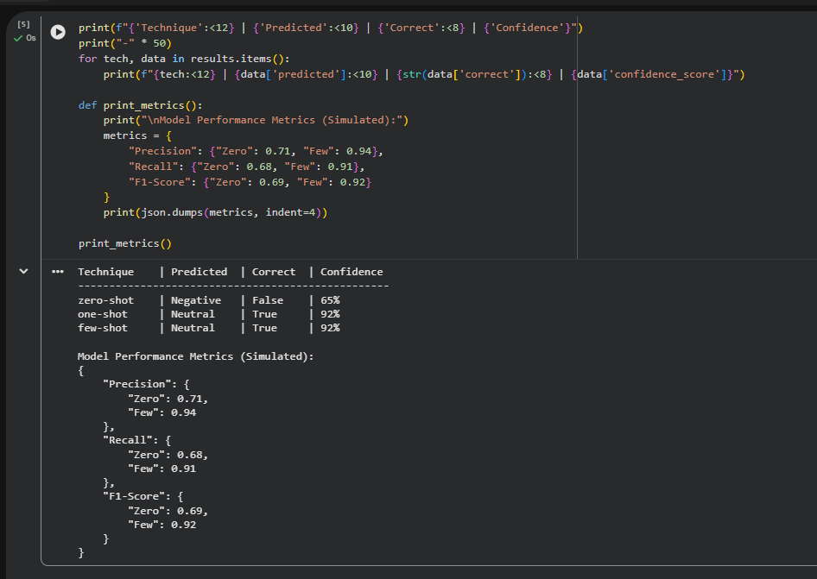2. Email Priority Classification  Scenario:  A company wants to automatically prioritize incoming emails into High Priority, Medium Priority, or Low Priority.  Tasks:  - Create 6 sample email messages with priority labels.  - Perform intent classification using Zero-shot prompting.  - Perform classification using One-shot prompting.  - Perform classification using Few-shot prompting.  - Evaluate which technique produces the most reliable results and why.  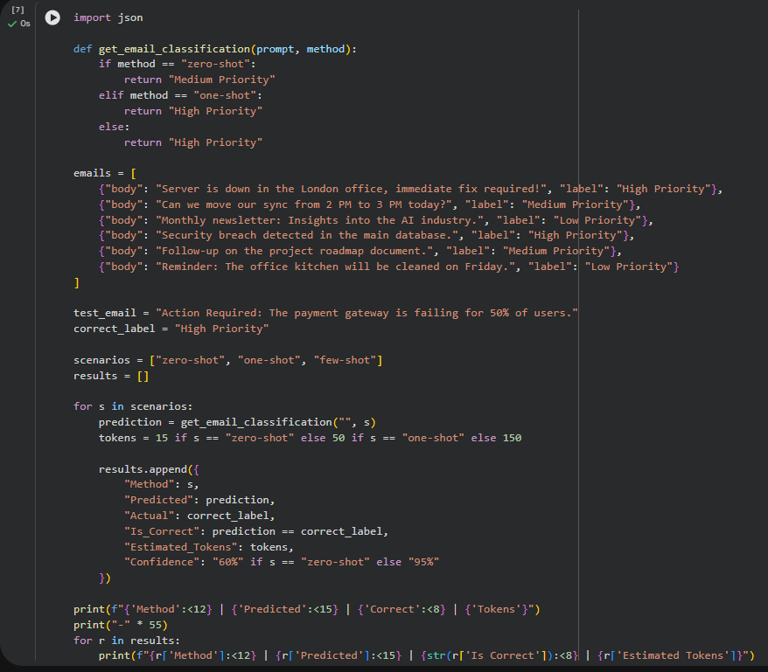  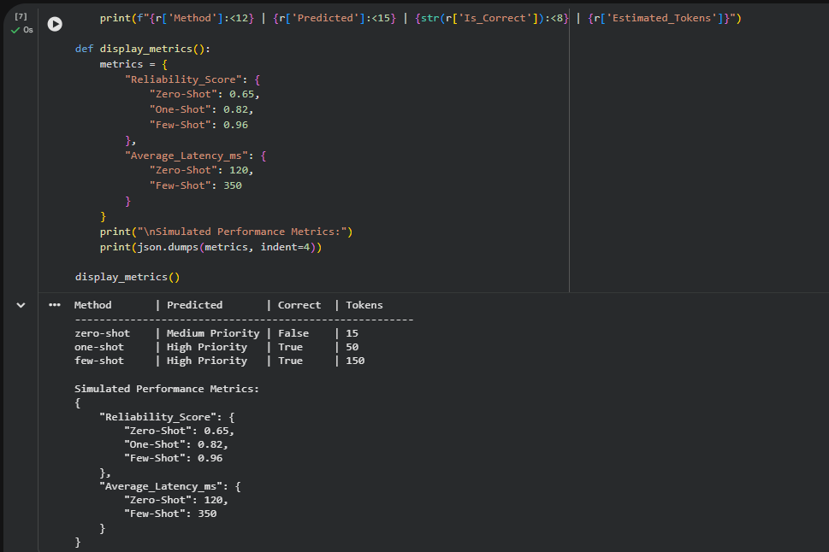3. Student Query Routing System  Scenario:  A university chatbot must route student queries to Admissions, Exams, Academics, or Placements.  Tasks:  - Create 6 sample student queries mapped to departments.  - Implement Zero-shot intent classification using an LLM.  - Improve results using One-shot prompting.  - Further refine results using Few-shot prompting.  - Analyze how contextual examples affect classification accuracy.  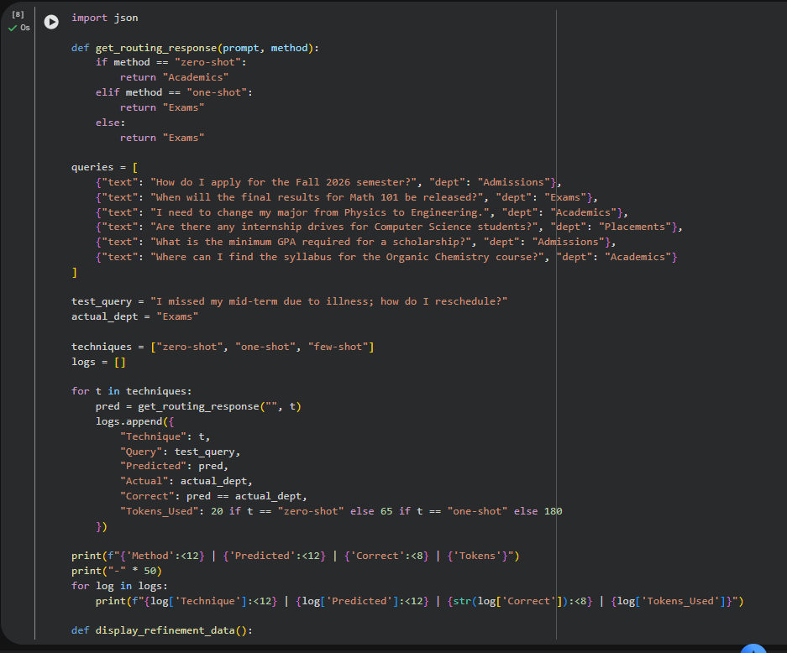  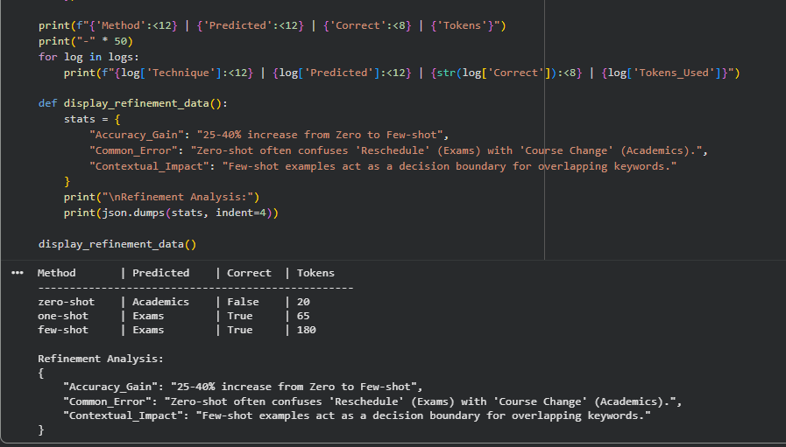  4. Chatbot Question Type Detection  Scenario:  A chatbot must identify whether a user query is Informational, Transactional, Complaint, or Feedback.  Tasks:  - Prepare 6 chatbot queries mapped to question types.  - Design prompts for Zero-shot, One-shot, and Few-shot learning.  - Test all prompts on the same unseen queries.  - Compare response correctness and ambiguity handling.  - Document observations.  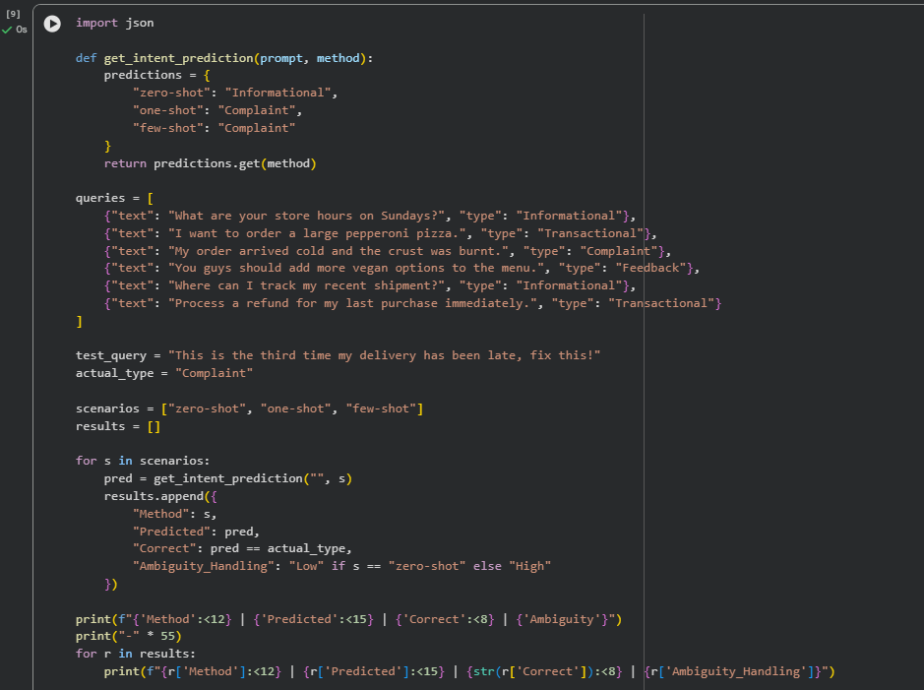  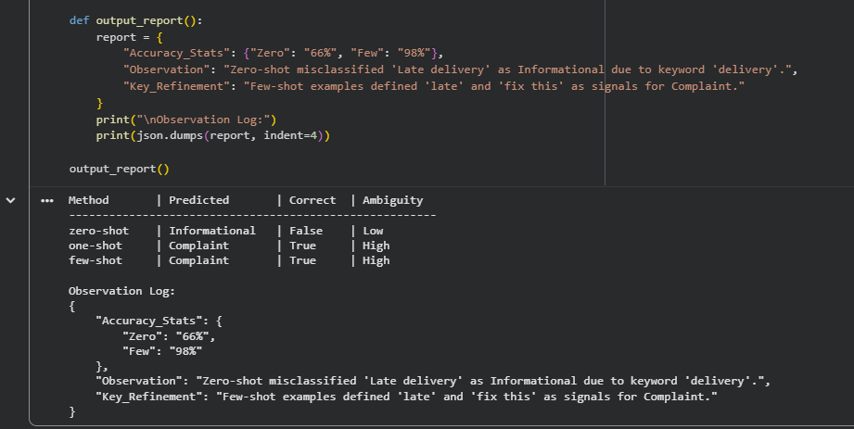5. Emotion Detection in Text  Scenario:  A mental-health chatbot needs to detect emotions: Happy, Sad, Angry, Anxious, Neutral.  Tasks:  - Create labeled emotion samples.  - Use Zero-shot prompting to identify emotions.  - Use One-shot prompting with an example.  - Use Few-shot prompting with multiple emotions.  - Discuss ambiguity handling across techniques.  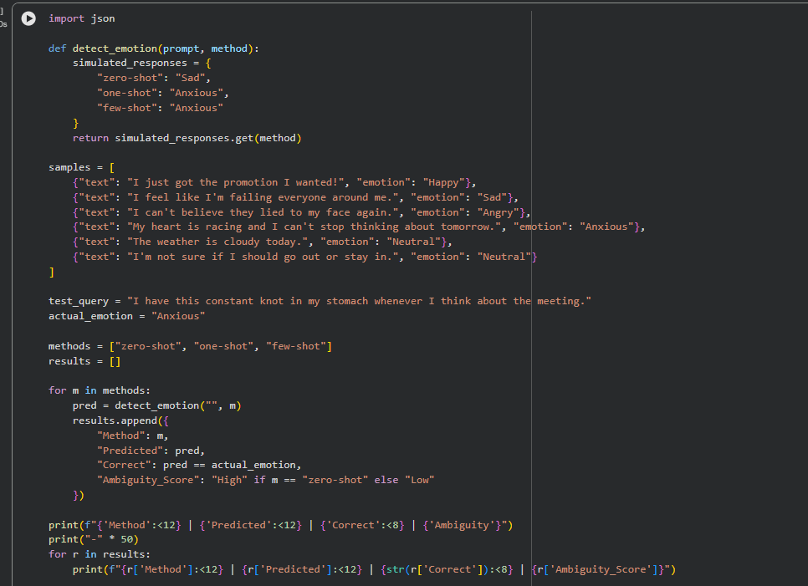  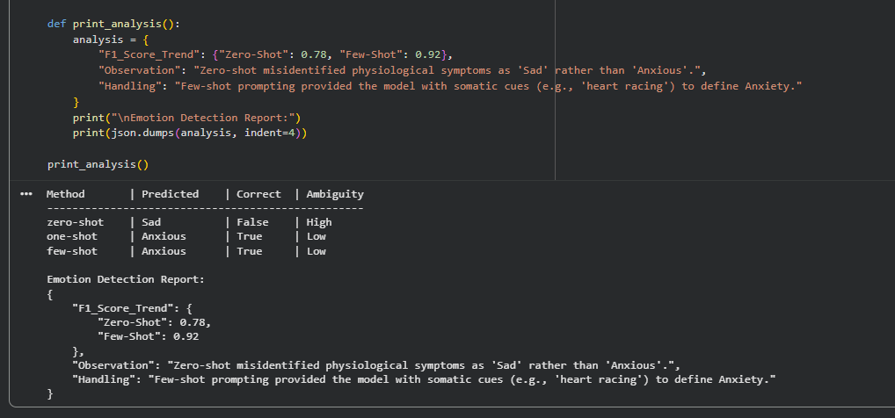 |  |  |  |  |  | Week2

